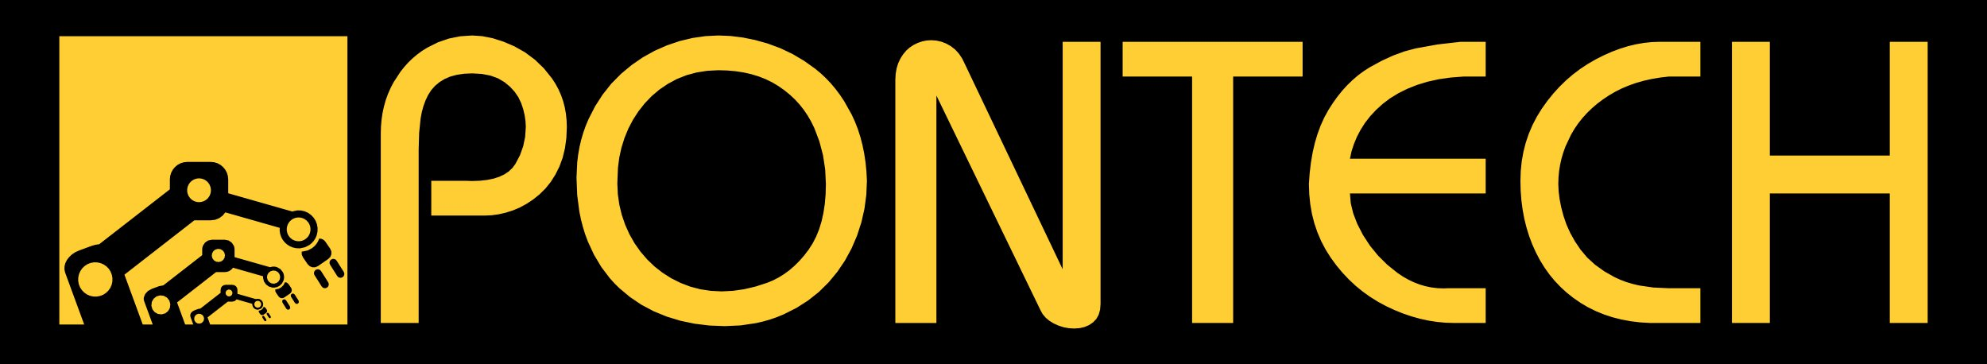

UAV100
Firmware Upgrade Guide
December 28th, 2011

Putting the UAV100 board into the Bootloader mode

Disconnect UAV100 from PC is it is connected to

Reconfigure COM port of selected board

Launch the device manager
Click start and type "device manager" into the Window search bar then press the enter key.
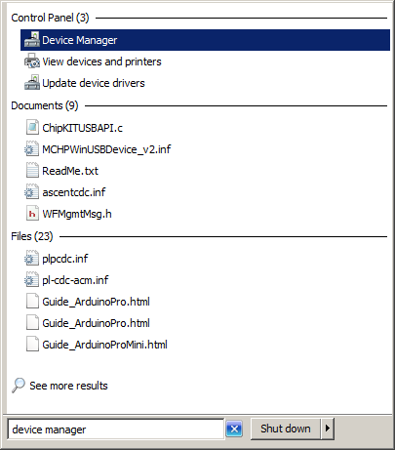

Find UAV100 USB COM Port
If the "PORTS (COM & LPT)" tree item is visible click the plus next to it to it to view all ports available on the PC.

Connect UAV100 to Windows PC using USB Cable
Look for the port called "Stk500v2". If this port is COM1, COM2 or COM3 you do not need to change the port number otherwise proceed to the next section.
If the program asks for a driver you will need to use the Stk500v2.inf file from the pontech.com web site.

Changing the COM port number
Right click on the "Stk500v2" com port and select the properties option.
Click on the "Port Settings" tab then click on the "Advanced" button. Then choose either COM1, COM2 or COM3 from the "COM Port Number" Drop Down.

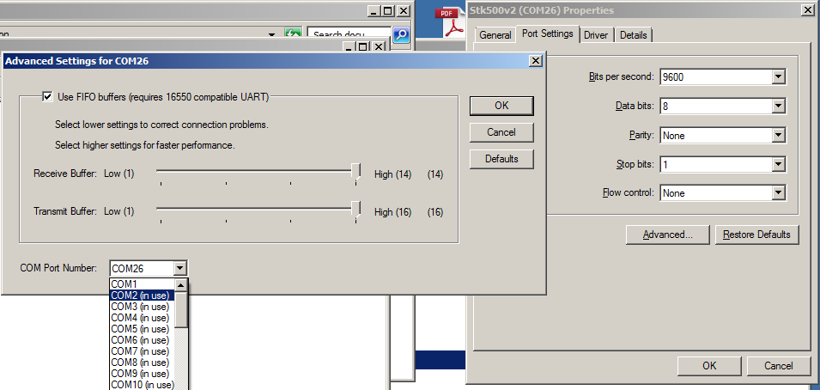

Short programming connections.
Using a paper clip or tweezers short pin 3 and pin 6 of the programming connector then press the reset button. This will cause the UAV100 to disconnect from the PC and reconnect in bootloader mode.
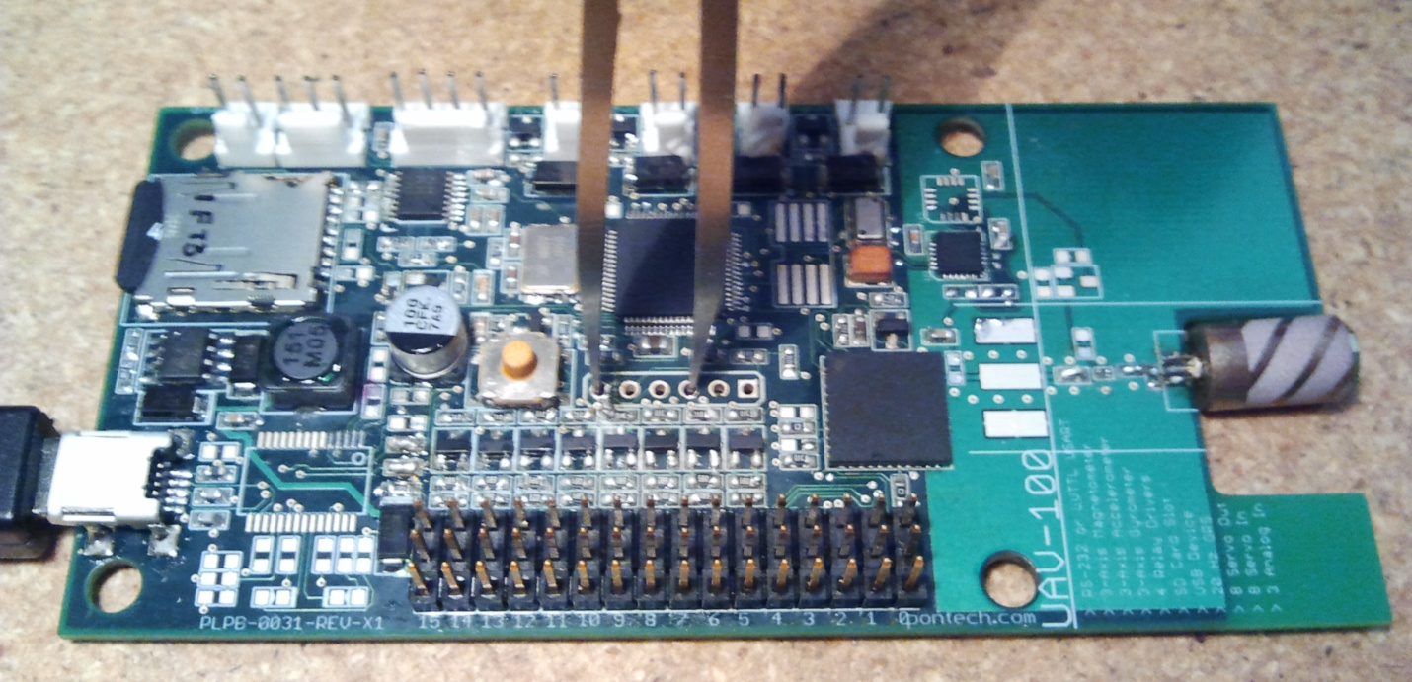
6 5 4 3 2 1
RESET

Upgrading Firmware

Download avardude-gui tool from pontech.com

Unzip avrdude-gui tool.

Double click on the avrdude-gui.exe

Configure avrdude-gui
On the "Setup" tap set the "Programer:" dropdown to "stk500v2" and set the "Port:" drop down to the COM port the UAV100 is connected too.
On the "Programming" tab se the "Target Device" dropdown to "32MX440F512H" and set the "File Format to use:" dropdown to "Intel Hex".
In the "Flash" group, click the "..." button and choose the hex file you wish to upload to the board.
In the "Flash" group, click the "Program" button. A new window will open and attempt to communicate with the UAV100 and upload the new hex file to the board.
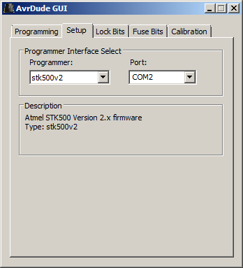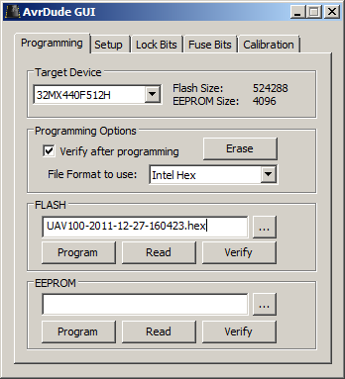
Cycle power on the board to launch the new application.

